1. ***For the given JSON iterate overall for loops (for, for in, for of, forEach)***

*the below codes have been copied from my vs code thus background is like that

**var json_file = {**

**"firstName": "Himal",**

**"lastName": "Gautam",**

**"age": 20,**

**"address": "Bharuch, Gujarat",**

**"phoneNumbers": 1234567890,**

**"spouse": null**

**}**

***Using For loop***

**let keys = Object.keys(json_file);**

**for (let i = 0; i < keys.length; i++) {**

**let x = keys[i];**

**console.log(x + ": "+ json_file[x]);**

**}**

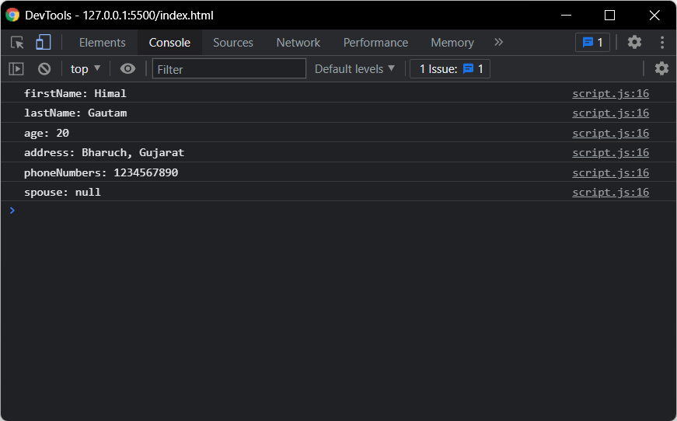

***Using For in loop***

for (let key in json_file) {

console.log(key + ": "+ json_file[key])

}



***Using For Of loop***

***for (let key of Object.keys(json_file)) {***

***console.log(key + " : "+ json_file[key]);***

***}***



***Using For each***

***let keys = Object.keys(json_file);***

***keys.forEach((key) => {***

***console.log(key + " : "+json_file[key]);***

***});***



1. ***Create your own resume data in JSON format***

**var resume = {**

**"firstName": "Himal",**

**"lastName": "Gautam",**

**"age": 20,**

**"address": "Bharuch, Gujarat",**

**"phoneNumbers": 1234567890,**

**"spouse": null**

**}**

1. ***Read about the difference between window, screen, and document in javascript***

Window object has a bunch of properties in it it's sort of the top-level and two of those properties are the document and the screen so the document in the screen is properties of the window.

The document is constructed after the window and it represents your content on the page usually the stuff you see although it's not exclusively stuff that is visible so most of the time it's gonna be HTML it could be XML it could be another markup language.

Screen object so again it's part of the window you can access it just through the screen and it contains information about the screen that you are currently sort of using whatever window this is referencing.

1. ***Codekata practice***